OPERATING SYSTEM
1.Create a new process by invoking the appropriate system call. Get the processidentifier of the currently running process and its respective parent using systemcalls and display the same using a C program.
#include <stdio.h>
#include <unistd.h>

int main()
{
pid_t pid;

pid = fork();

if (pid == 0)
{
printf("Child Process\n");
printf("Process ID: %d\n", getpid());
printf("Parent Process ID: %d\n", getppid());
}
else
{
printf("Parent Process\n");
printf("Process ID: %d\n", getpid());
printf("Parent Process ID: %d\n", getppid());
}

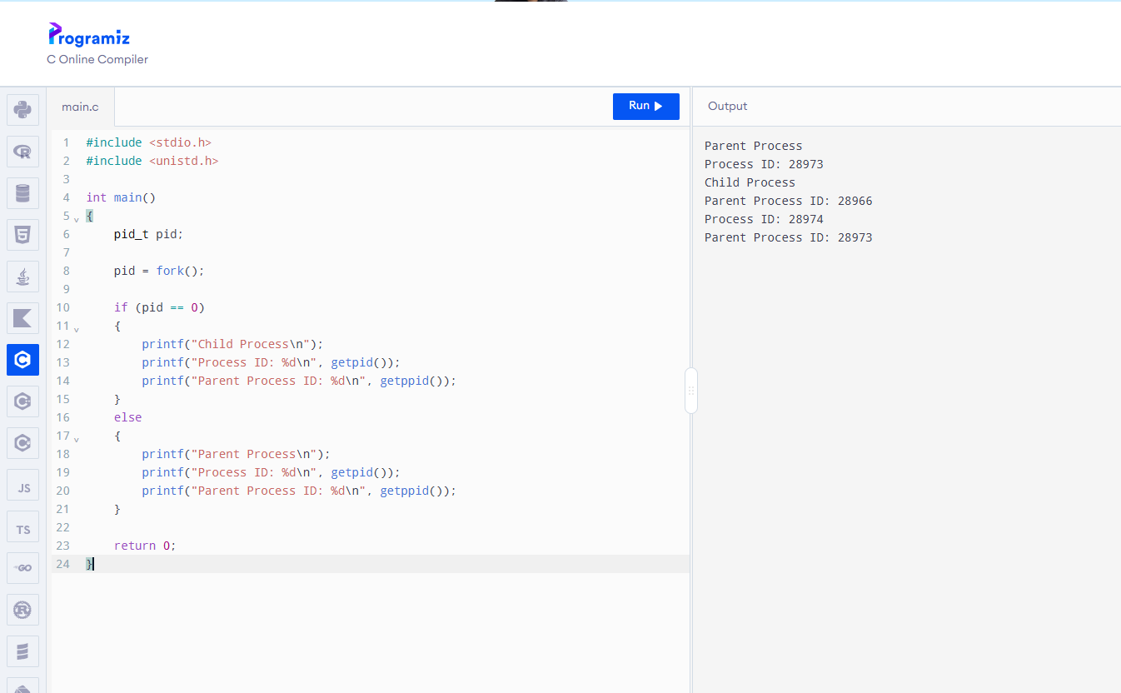

2 Identify the system calls to copy the content of one file to another and illustrate the same using a C program.

#include <stdio.h>
#include <fcntl.h>
#include <unistd.h>

int main()
{
int source, destination;
char buffer[100];
int n;

source = open("source.txt", O_RDONLY);
destination = open("destination.txt", O_WRONLY | O_CREAT, 0644);

if (source < 0 || destination < 0)
{
printf("Error opening file\n");
return 1;
}

while ((n = read(source, buffer, sizeof(buffer))) > 0)
{
write(destination, buffer, n);
}

close(source);
close(destination);

printf("File copied successfully\n");

return 0;
}

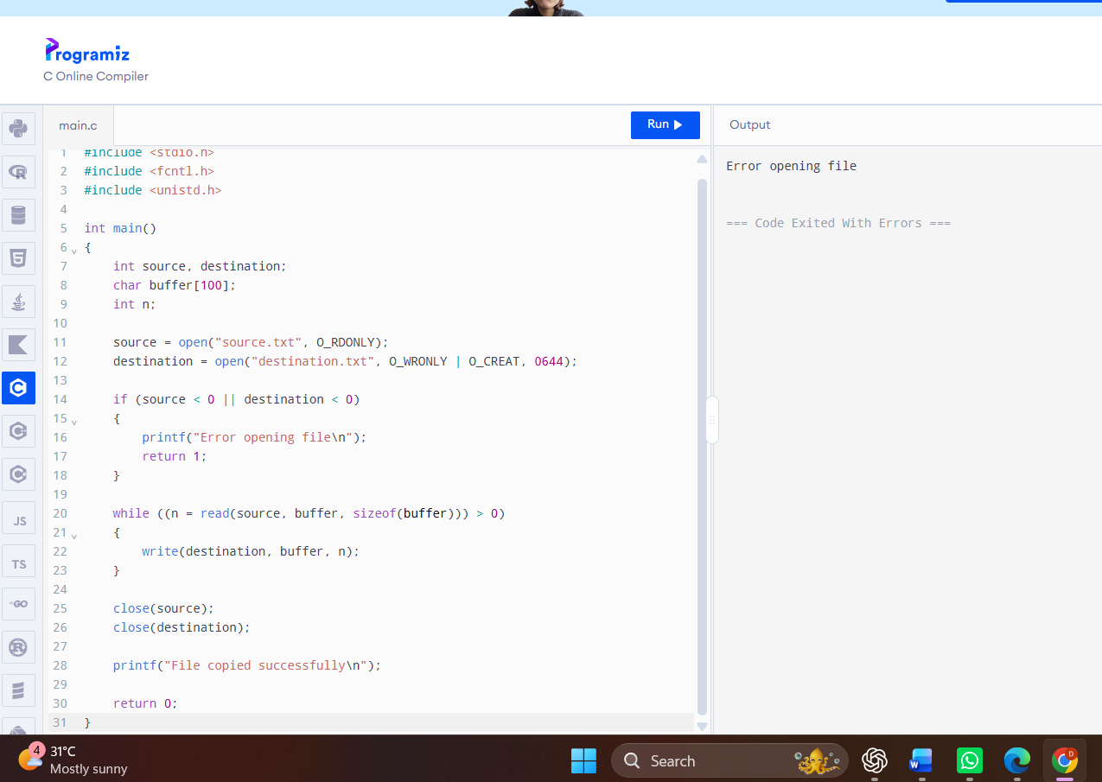

3 Design a CPU scheduling program with C using First Come First Served
technique with the following considerations.
a. All processes are activated at time 0.
b. Assume that no process waits on I/O devices

#include <stdio.h>

int main()
{
int n, i;
int bt[20], wt[20], tat[20];
float avgwt = 0, avgtat = 0;

printf("Enter number of processes: ");
scanf("%d", &n);

printf("Enter burst time of each process:\n");

for (i = 0; i < n; i++)
{
printf("P%d: ", i + 1);
scanf("%d", &bt[i]);
}

wt[0] = 0;

for (i = 1; i < n; i++)
{
wt[i] = wt[i - 1] + bt[i - 1];
}

for (i = 0; i < n; i++)
{
tat[i] = wt[i] + bt[i];
avgwt = avgwt + wt[i];
avgtat = avgtat + tat[i];
}

printf("\nProcess\tBurst Time\tWaiting Time\tTurnaround Time\n");

for (i = 0; i < n; i++)
{
printf("P%d\t%d\t\t%d\t\t%d\n",
i + 1, bt[i], wt[i], tat[i]);
}

printf("\nAverage Waiting Time = %.2f", avgwt / n);
printf("\nAverage Turnaround Time = %.2f\n", avgtat / n);

return 0;
}
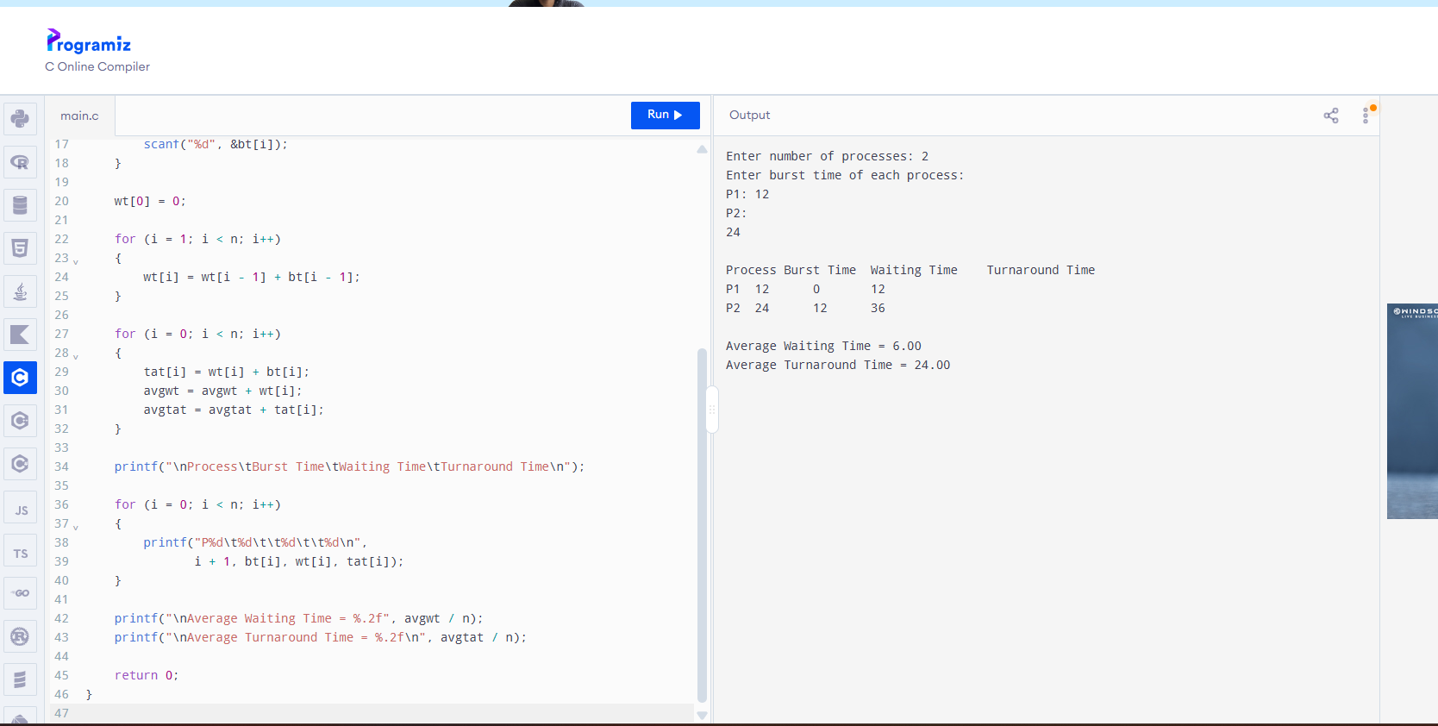
4 Construct a scheduling program with C that selects the waiting process with the
smallest execution time to execute next

#include <stdio.h>

int main()
{
int n, i, j;
int bt[20], p[20], wt[20], tat[20];
int temp;
float avgwt = 0, avgtat = 0;

printf("Enter number of processes: ");
scanf("%d", &n);

printf("Enter burst time of each process:\n");

for (i = 0; i < n; i++)
{
p[i] = i + 1;
printf("P%d: ", i + 1);
scanf("%d", &bt[i]);
}

/* Sort processes according to burst time */
for (i = 0; i < n - 1; i++)
{
for (j = i + 1; j < n; j++)
{
if (bt[i] > bt[j])
{
temp = bt[i];
bt[i] = bt[j];
bt[j] = temp;

temp = p[i];
p[i] = p[j];
p[j] = temp;
}
}
}

wt[0] = 0;

for (i = 1; i < n; i++)
{
wt[i] = wt[i - 1] + bt[i - 1];
}

for (i = 0; i < n; i++)
{
tat[i] = wt[i] + bt[i];
avgwt += wt[i];
avgtat += tat[i];
}

printf("\nProcess\tBurst Time\tWaiting Time\tTurnaround Time\n");

for (i = 0; i < n; i++)
{
printf("P%d\t%d\t\t%d\t\t%d\n",
p[i], bt[i], wt[i], tat[i]);
}

printf("\nAverage Waiting Time = %.2f", avgwt / n);
printf("\nAverage Turnaround Time = %.2f\n", avgtat / n);

return 0;
}
